1. **Wipro – Applying Thought**

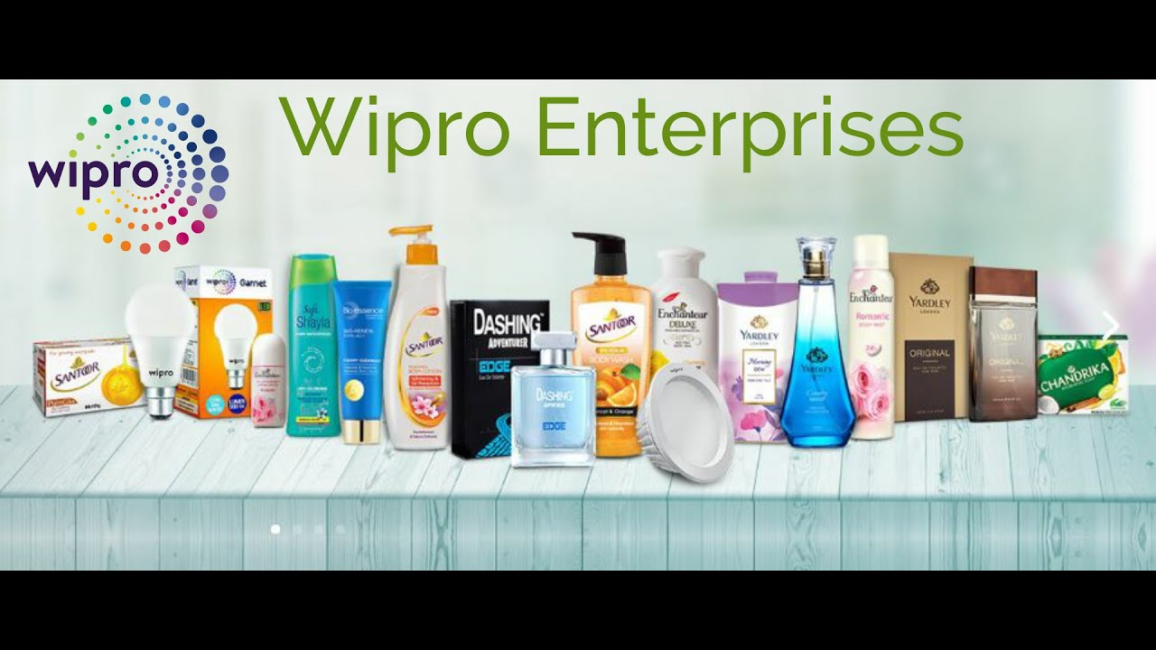

W

IPRO(Western India Palm Refined Oils Ltd) is an Indian multinational corporation that provides information technology.

Consultant and business process services is one of the leading big tech companies.

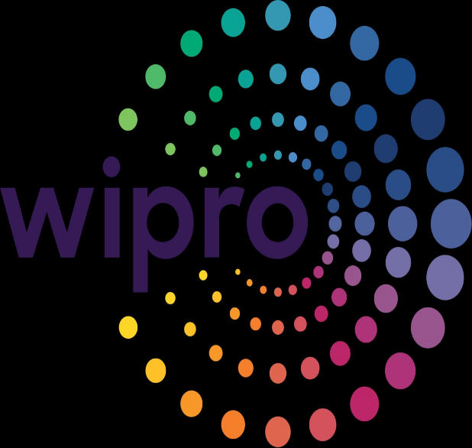

The primary brand goals or objectives of the brand: Wipro Ltd is a global information technology, consulting and business process services company. According to Wipro’s website the company’s vision is to be globally respected corporation that provides best products, solutions, services and to be the most trusted partner for its stake holders.

KIPs uses to measure progress towards the goals: Wipro follows 5 level grid. Every employee is rated in this grid.

Peoples who already use these products has shared their experiances with others in the comment section. Those are called as feedback. They send the feedback to the company also and they give the reactions of emojis, hearts etc., if they were impressed.

1. **Maruthi Suzuki – Way of Life**



M

aruthi Suzuki India Ltd is the Indian subsidiary of Japanese auto maker Suzuki motor corporation as of Sep 2022, the company has a leading market share of 42% in the Indian passenger car market.

The primary brand goals or objectives of the brand: The main goal of Maruthi Suzuki is to promote electrification in response to environmental issues in India. They aim to maintain a market share of over 50% in India’s passenger vehicle segment. The company’s mission since it’s inception has been “TOMOTORIZE THE COUNTRY”.

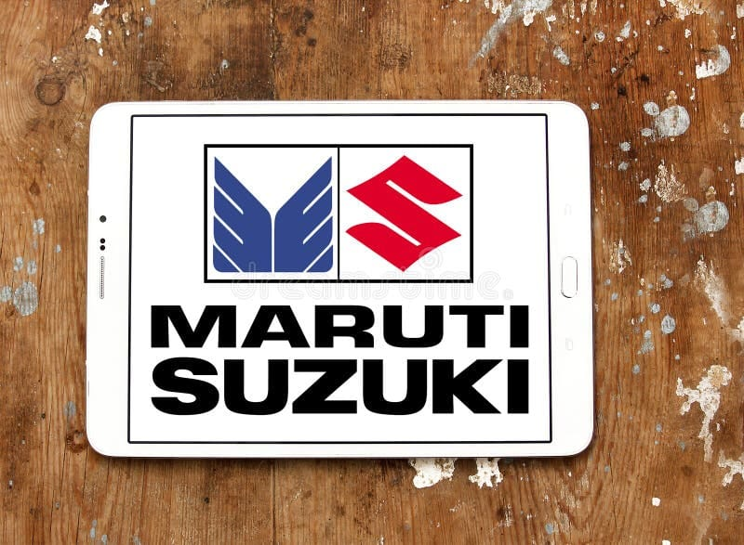

KPIs uses to measure progress towards the goals: If your business runs on a subscription based model, you might benefit from measuring your monthly recurring revenue (MMR). This metric refers to the company’s total revenue during a specific period. Individually, these sales indicators allow business to monitor specific changes in customer behaviour and make adjustments accordingly. Tally the total instance of contact with a potential customer. The percentage of leads converted from leads generated in your conversion rate. It can demonstrate how effective you are at both reaching and retaining a customer. The inverse of your conversion rate is your bounce rate, which measures the no. of visitors who navigate to your company’s web page but leave immediately without interacting. The no. of bounces as a percentage of your leads generated can be used to identify gaps in your marketing, advertising and user experience.

1. **Coco-Cola**

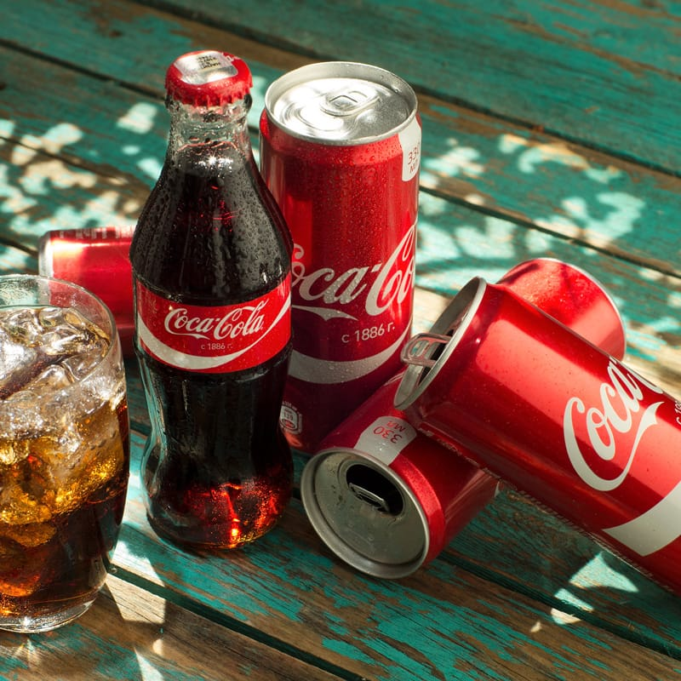

C

Oco – Cola or Coke is a carbonated soft drink manufactured by Coco – Cola Company. in 2013, Coke products were sold in over 200 countries worldwide, with consumers drinking more than 1.8billion company beverage serving each day.

The primary brand goals or objectives of the brand: Maintaining its position as a global leader in the beverage industry by offering a diverse portfolio of refreshing and high-quality beverages. Advancing sustainability efforts by reducing its environmental impact, improving water efficiency, and promoting responsible sourcing and packaging. Fostering strong brand loyalty and customer engagement through marketing, innovation and responsiveness to changing consumer preferences.

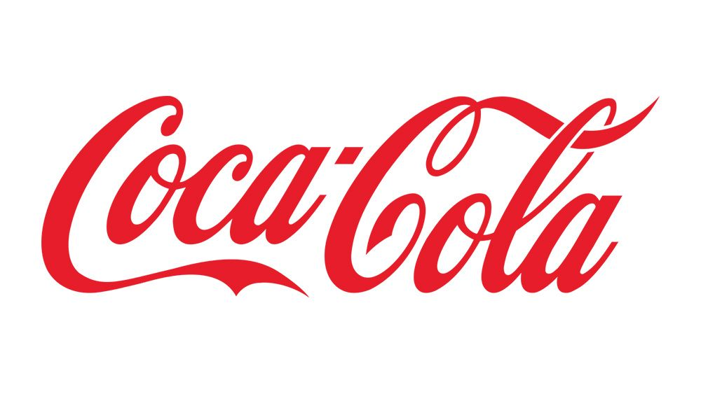

1. **Dell**

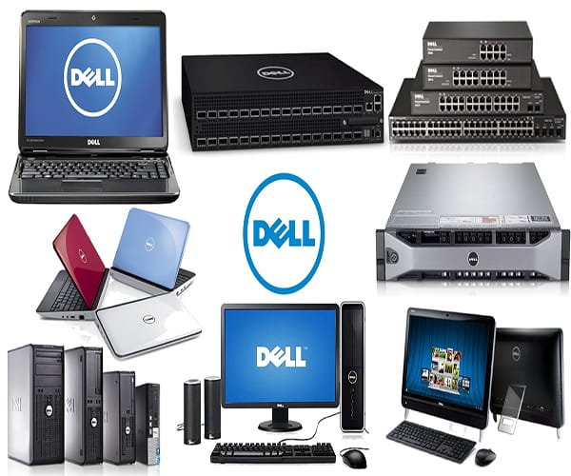

D

ell Inc. is an American based technology company. It develops, sells, repairs and supports computers and related products and services. Dell is owned by its parent company, Dell Technologies. It sells PCs, servers, data storage devices, network switches, software, computer peripherals, HDTVs, cameras, printers and electronic commerce.

The primary goals or objectives of the brand: Dell offers a diverse range of products, primarily focused on technology and computing solutions. Dell’s product offerings include laptops, desktop computers, servers, data storage solutions, monitors and peripherals, with a focus on delivering reliable, customizable and performance driven technology solutions to individuals and businesses worldwide.

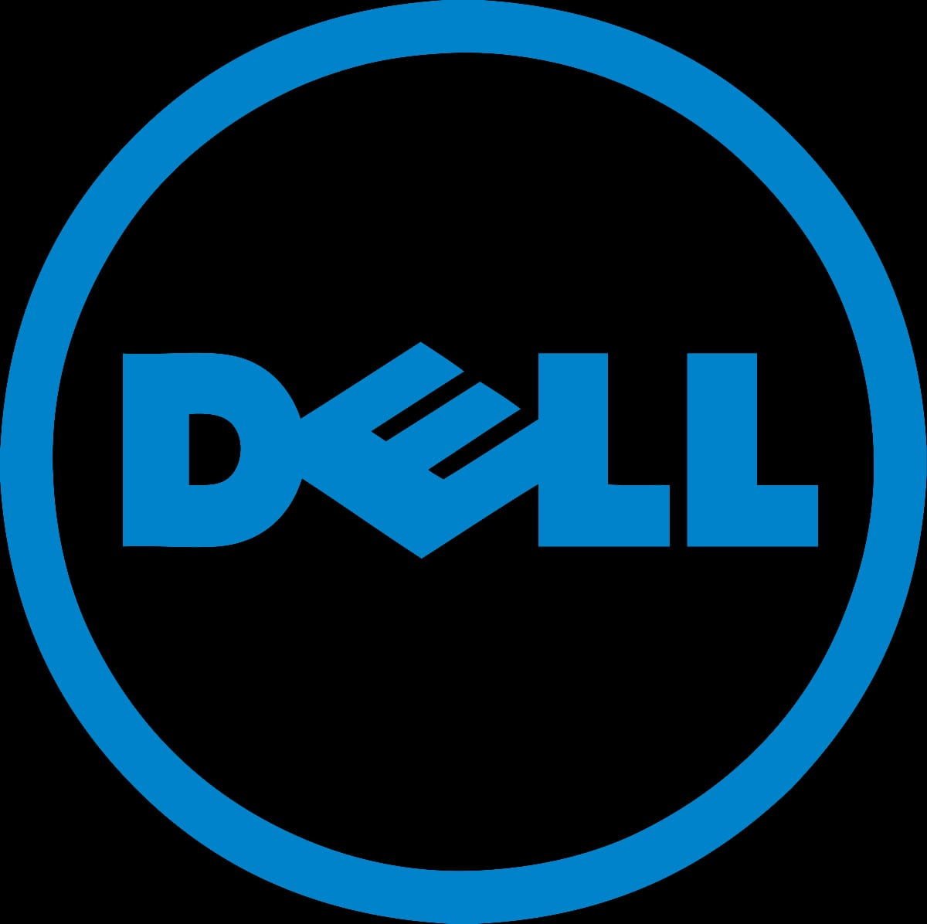

KPIs uses to measure progress towards the goals: Revenue and profit growth track financial performance through metrics such as revenue, profit margins and earnings to evaluate the company’s financial health and market competitiveness. Customer satisfaction measures consumers feedback, support satisfaction and product quality ratings to asses customer experience and loyalty. Monitoring supply chain metrics such as inventory turnover, lead times and supplier performance to optimize operational efficiency and reduce costs.

1. **Nike – Just do it**

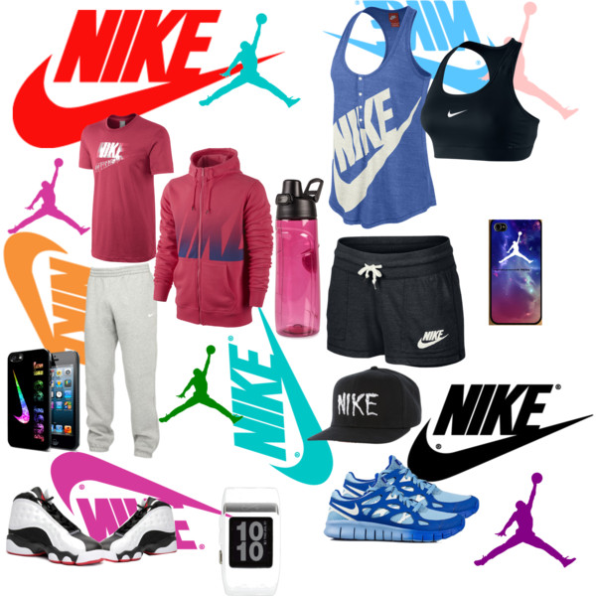

N

ike is the world’s largest athletic apparel company and best known for its footwear, apparel and equipment. It is founded in 1964 as Blue Ribbon Sports, the company became Nike in 1971 after the Greek Goddess of Victory. Nike Inc. engages in the design, development, marketing and sale of athletic footwear, apparel, accessories, equipment and services. ***Inspiration, Innovation, Empowerment*** are these just a few words that describe Nike’s branding.

The primary brand goals or objectives of the brand: Nike’s purpose is to “Unite the world through sport to create a healthy planet, active communities and an equal playing field for all.” This is reflected in the company’s mission and vision statements which loosely include maximizing human potential, improving lives through sports and creating a better future.

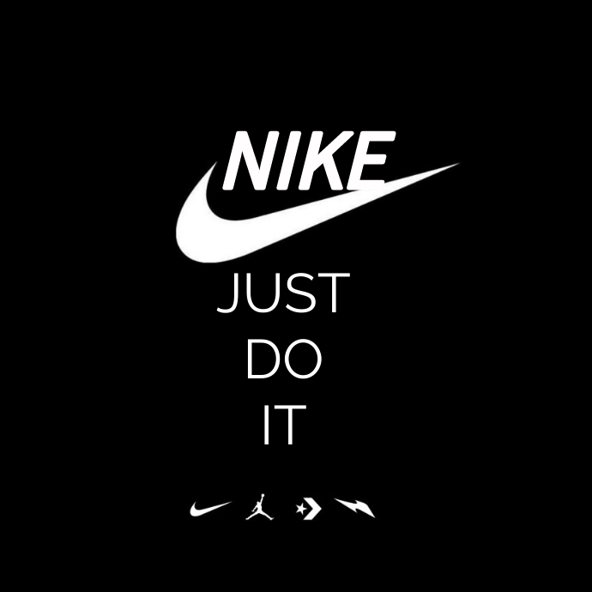

KPIS uses to measure progress towards the goals: The breakeven point accounts for the amt of money a company must earn in a given period. To cover its cost and sustain itself. Tracking whether your company is meeting, exceeding or falling short of this no. is key to measure success and creating actionable next steps for the experienced companies, the break even point maybe the minimum expectation while newer companies may aim supply to meet this goal consistently. The net income ratio or profit is the money left over when a company subtracts its expenses from its revenue. Business have traditionally viewed this metric for measuring value and it can be a quick indicator of whether your company is thriving. This is the measure of how likely your customers are to recommend your business.